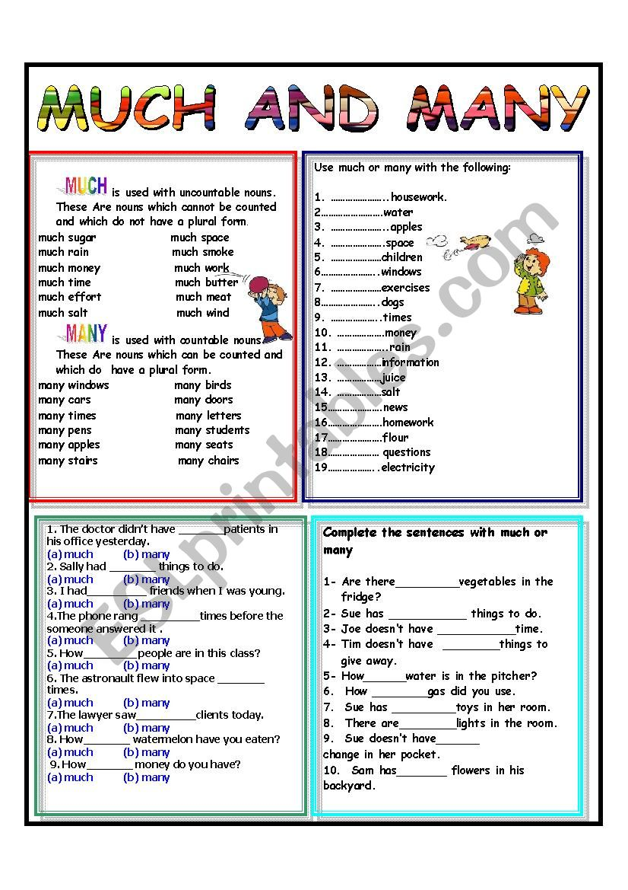 Much Housework

much Water

many Apples

much Space

many Children

many Windows

many Exercises

many Dogs

much Times

much Mony

much Rain

Much Information

Much Juice

Much Salt

much News

many Homework

much Flour

many Questions

much Electricity

ex2

1. many
2. much
3. many
4. much
5. many
6. much
7. many
8. much
9. much

ex3

1. much
2. many
3. much
4. many
5. much
6. much
7. many
8. much
9. ?
10. many